For this assignment, you will be using the **NYTimes API** to access some information.   
  
*The API is not public, so in order to use it, would you need to request an API key, which is easier than it sounds. Nevertheless, you need to provide some personal information about you to a 3rd party, so if you are not comfortable with that, I would suggest skipping this assignment and just looking at the response.*

Step 1 - Create an account

Go to <https://developer.nytimes.com/accounts/create> and **create a new account.**

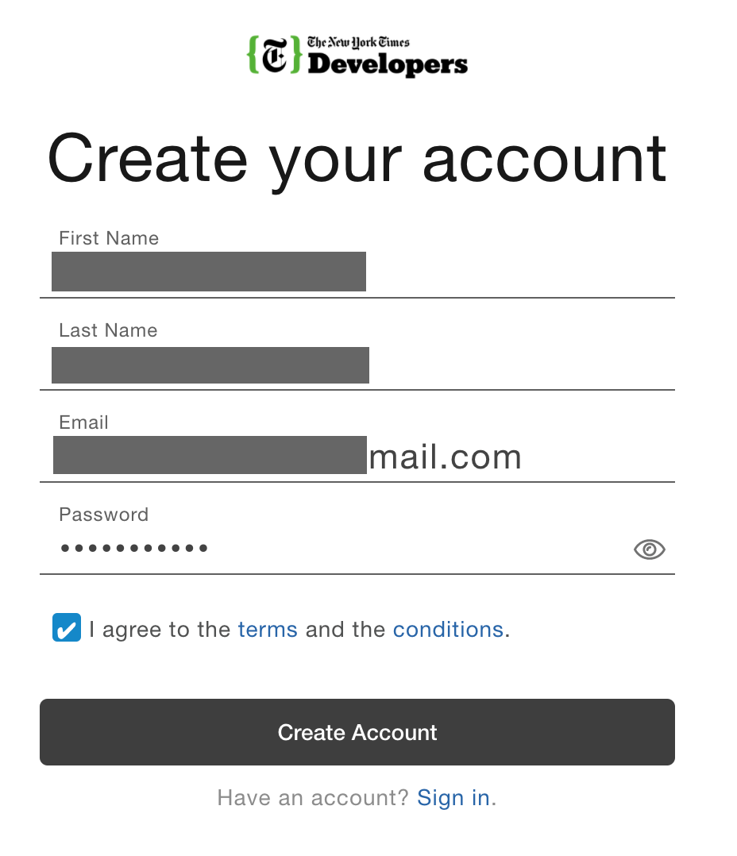

Submit the form to create an account.

Step 2 - Verify your account

In a few minutes, you will get an email with a link to verify your account.  **Click the link in the email.**

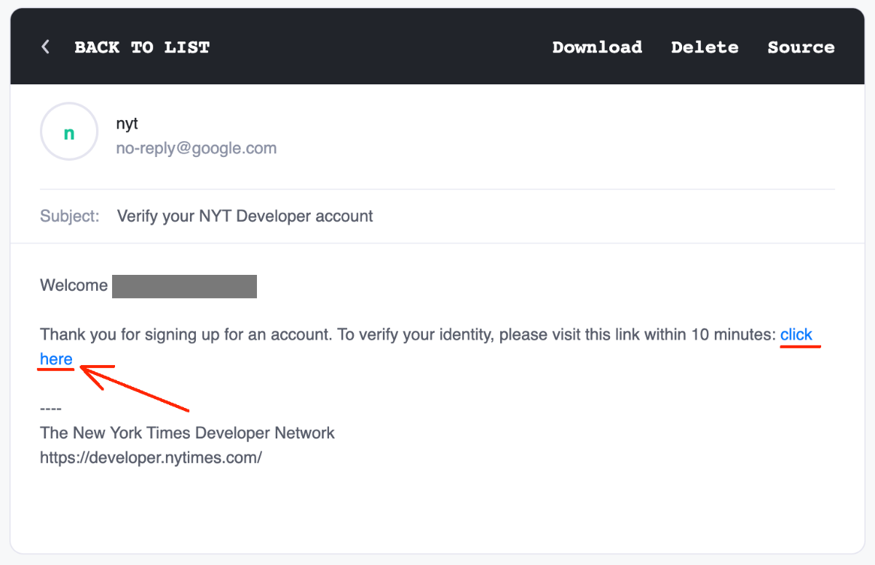

If you get an error after clicking the link in the email, don't worry. Typically your account has been verified.

Step 3 - Sign-in

**Sign-in into your account** <https://developer.nytimes.com/accounts/login> using the credentials provided.

Step 4 - Create a new app

Usually, APIs are used by apps. The "app" in our case is simply Postman since we are not building any other apps.

On the right corner, you should see your email. Click on the email as this will open a drop-down list with more options. **Click on *Apps*.**

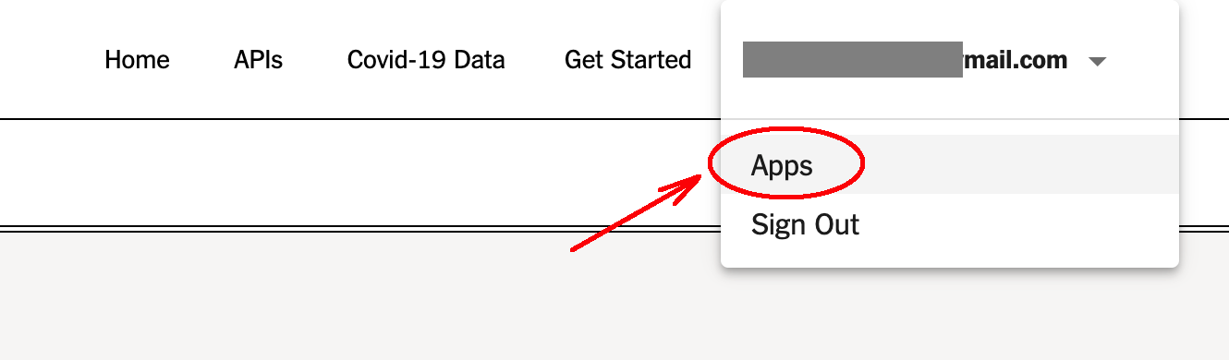

The following screen will be displayed.

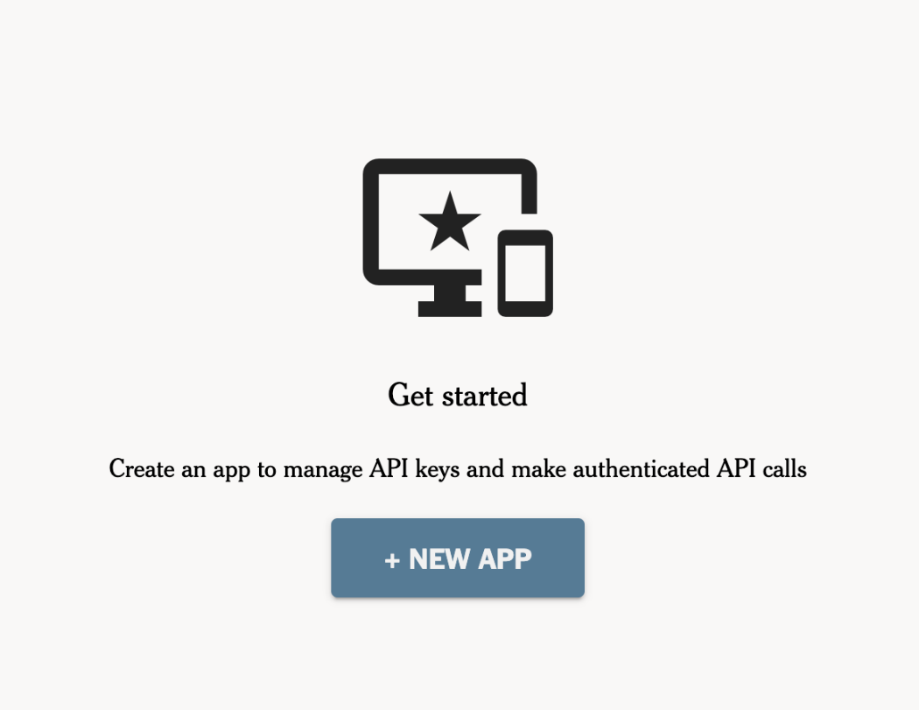

**Click on *NEW APP.***

On the following screen, **name your application** as you wish (I have used the name Postman).

**Click on the plus sign for the Books API.**

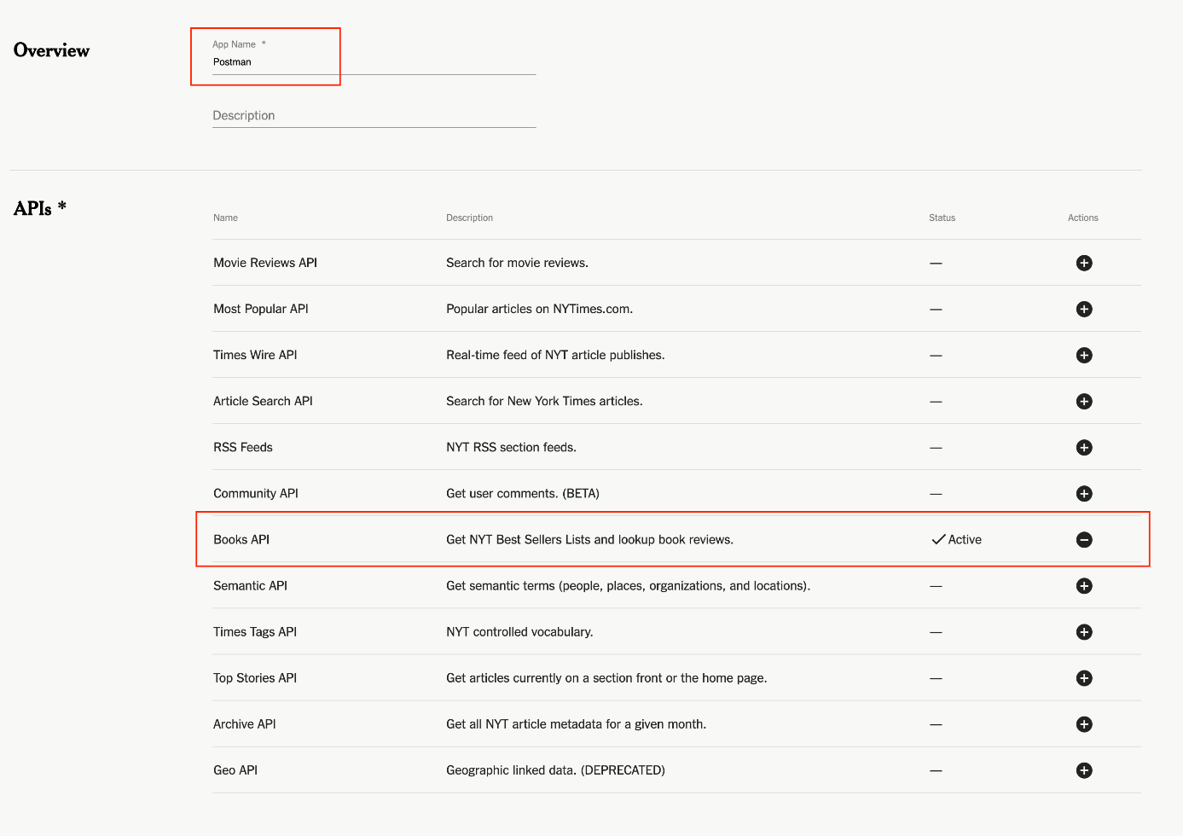

Finally, **click on Create.**

Step 5 - Get the API key

The next page will show you the API key and the secret. You will need this information to complete the assignment.

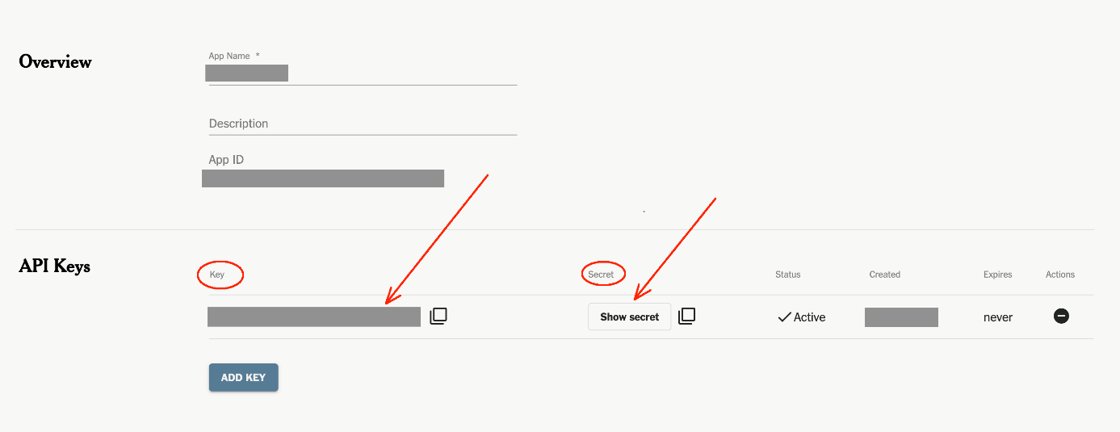

Keep this information only to yourself.

**Questions pour cet exercice**

Open a new tab in Postman and create a GET request with this URL:   
  
https://api.nytimes.com/svc/books/v3/lists.json

Submit the request.

**What is the status code that you get back?**

Error 401 Unauthorized

According to the error message you have received, the API is expecting your API key as a query parameter. The error that you see in the response body also indicates that is wrong.  
  
Go ahead and create a new query parameter called **api-key** and put the API key you have received in the Value field.

Now resubmit the request.

**What status code do you get now?**

Error 400 Bad Request

Try adding a GET query parameter called **list** with any value you want.

Resubmit the request.

**What status code do you see now?**

200 ok

Use **hardcover-nonfiction** as a value for **list**. You should get a list with multiple results.  
  
Inspect the values you see in the response and try to figure out proper values for the following additional get parameters:

*rank  
published-date  
rank-last-week*

Try to get one result listed with all parameters active!

**How does the response body look like?***Paste below the response body using the "Copy" response button, located right near the Save response and the magnifying glass.*

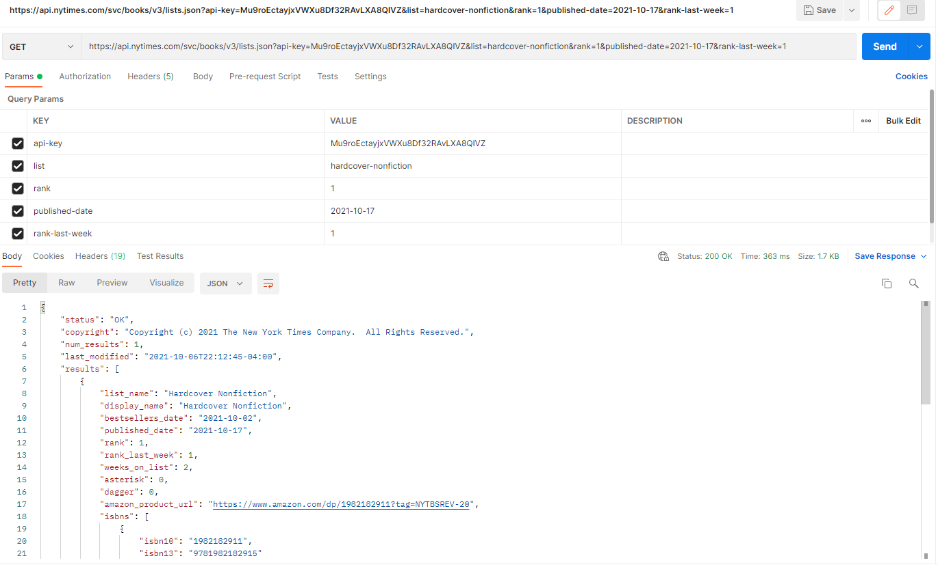

Hint: I hope you are using the Params panel to manage all these parameters! :)

Inspect the **RESPONSE headers**.  
  
**Which other request methods (apart from GET) are allowed when calling this resource?**

GET & OPTIONS

Inspect the **REQUEST headers** with the headers you are sending with Postman (and not the response header you get from the server).

**What value does the header User-Agent have?**

PostmanRuntime/7.28.4

**Tip:** If you do not find the header, make sure to revisit the lecture Troubleshooting inside this section.

How can you change the value of the header **User-Agent** value to something like '**My custom agent**' ?

Change the value of the user-agent in the headers panel

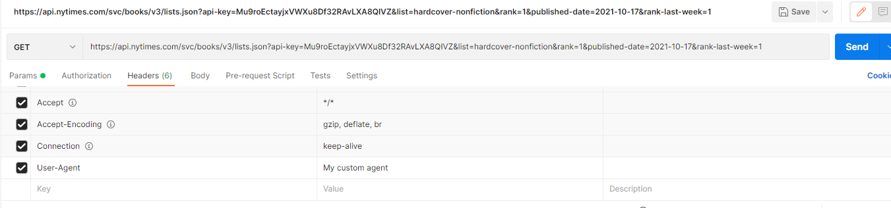

**How was this assignment?**

Not too hard.